Not Every Infinity Is a Set: From Cantor to Zermelo
Or

Which Infinite Totalities Are Sets?: From Cantor to Zermelo
  - CCST5037 Assignment 1 Group Project Plan

Group Members and tutorial
Ryan Zhao (UID: 3036297398); Dai Yuxuan, Tim (UID: 3036292116).
Tutorial: Toby Lai, Group 01, Wed 10:00-10:50 a.m.

Main work:

Using Dauben, Georg Cantor: His Mathematics and Philosophy of the Infinite (Harvard University Press, 1979), chapters 5 and 6, as a starting point for Cantor's distinctions, we compare two primary texts: Cantor to Richard Dedekind, 3 August 1899, and Zermelo, "Untersuchungen über die Grundlagen der Mengenlehre I" (1908). Aristotle, Physics III.4–8, and Gauss to H. C. Schumacher, 12 July 1831, are two brief and separate background views. The Hilbert Hotel, from Hilbert's 1924/25 lectures (published 2013), is only an opening illustration.

PROPOSED CENTRAL THEME AND ESSAY CONTENT
The central theme is what happened between Cantor's 1899 distinction of sets from inconsistent totalities and Zermelo's 1908 axioms, which made that restriction explicit as public rules. The essay will open with the Hilbert Hotel as one completed infinite collection, and ask: if it may be a set, may every collection be a set? Three steps follow. First, Cantor's letter to Dedekind of 3 August 1899 distinguishes multiplicities that can form one finished set from absolutely infinite, inconsistent ones, such as the totality of all ordinals. Second, Zermelo's 1908 axioms state the boundary as rules: the Axiom of Infinity postulates that an infinite set exists, and separation blocks unrestricted set formation. Third, the essay will ask what those public rules added to Cantor's then-unpublished distinction, taking the set of all natural numbers as its working example, contrasted in Figure 1 with a totality the 1908 system does not admit as a set. The essay stays with these two texts and does not survey later axiomatic set theory.
This addresses CLO 2: what may count as a set was settled by argument and revision among mathematicians, not discovered once and left unchanged, and the essay follows that process. Aristotle, Physics III.4–8, and Gauss's 1831 letter to Schumacher appear as two separate background objections, showing that resistance to completed infinity took more than one form before Cantor.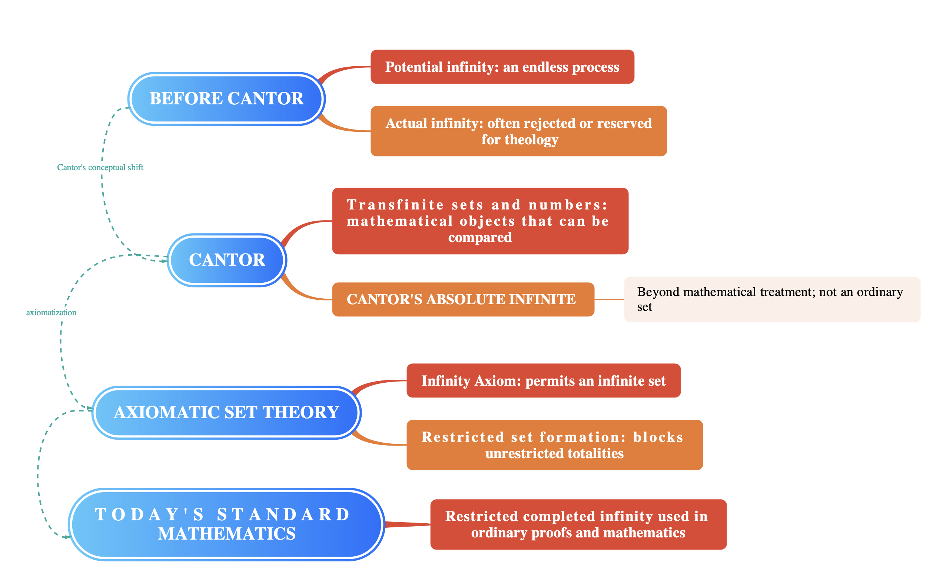
Figure 1 Conceptual change in the meaning of infinity.

